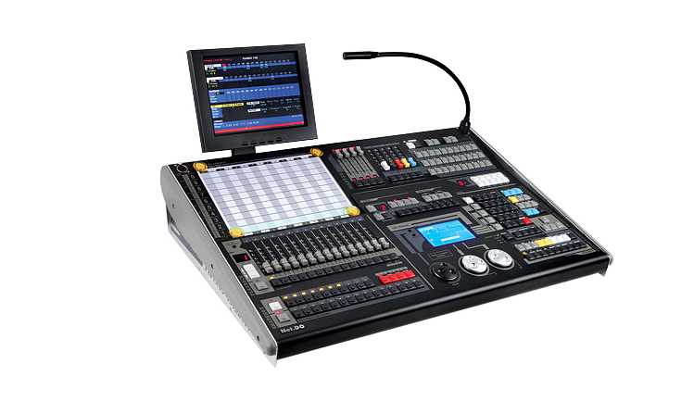

CEE CP5000

CP5000 MOVING LIGHT CONTROLLER:
Function and performance:
2048 DMX channels, DMX512/1990 standard, Output port with optical isolated.
Up to 240 intelligent Fixtures or 240 Dimmer may be connected.
Up to 42 channels each Fixture. Fixture Library mode, “pearl” Fixture Library compatible.
600 Playback program, 200 Group, 210 Preset, 100 Snapshot.
With a playback of the list display, Users can view and write playback list.
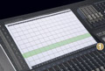
100 Scene-snapshots can be directly used keys running (flash or latch).
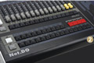
With attribute fader of fixture (including dimmer, shutter, magenta, yellow and cyan). Used to quickly control the LED fixture.
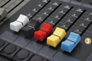
Up to 180 SHAPE generators. SHAPE is provided to control such effects as circles, lines and dimmer effect, etc.
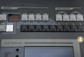
Chase trigger mode selectable: Auto1, Auto2, Music synchronously and MIDI.

USB port is provided. USB-disk can record the data of controller, Controller can be upgraded through the USB port.

1 VGA port, user can connect it to the colorful CRT or LCD displays (OPTIONAL).
LCD display with backlight.
12V accessory operate light (OPTIONAL).
Power supply: AC 110-240V / 50-60Hz
Dimension: 820mm x 540mm x 175mm
